Case 9-MEX-Teotihuacan-Tlaloc-Terra cotta-100 CE
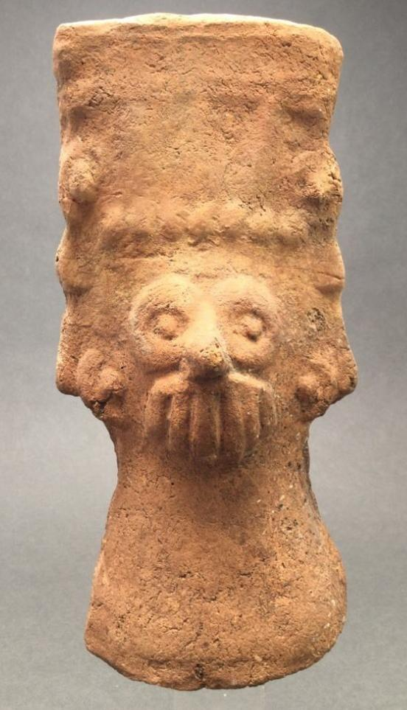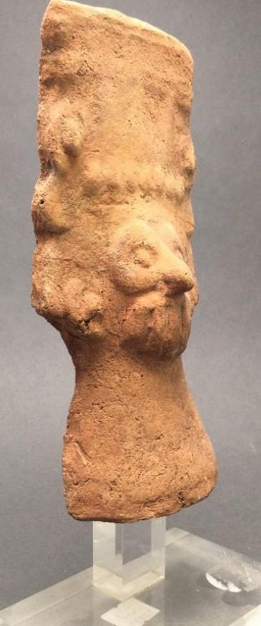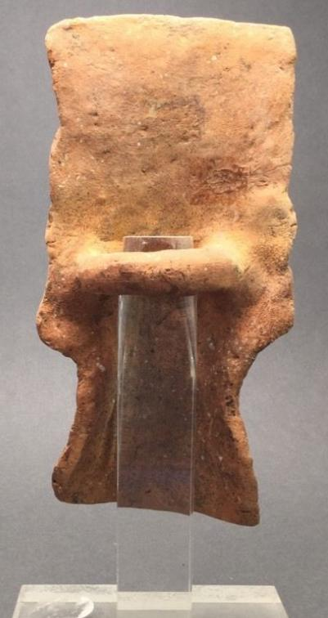
MEX-Teotihuacan-Tlaloc-Terra cotta-100 CE
Case No.: 9
Accession Number:
Formal Label: MEX-Teotihuacan-Tlaloc-Terra cotta-100 CE
Display Description:
This terra cotta Tlaloc from the area around Teotihuacn was the product of early settlers of the city, perhaps the Otomi.
LC Classification:
Date or Time Horizon: 100 CE
Geographical Area: Teotihuacan
Map:
GPS Coordinates:
Cultural Affiliation: Teotihuacan
Medium: terra cotta
Dimensions: H 7.5 in without base
Weight:
Provenance: Ex. Melvin Dwork collection, Shelter Island , NY
Condition: original
Discussion:
References:

Home > My eBay > Order details

Order details

Sales order
Sold by bibliovendor ( 865 )

Delivery package 1 of 1
Estimated delivery Saturday, Apr 9, 2016 - Wednesday, Apr 13, 2016
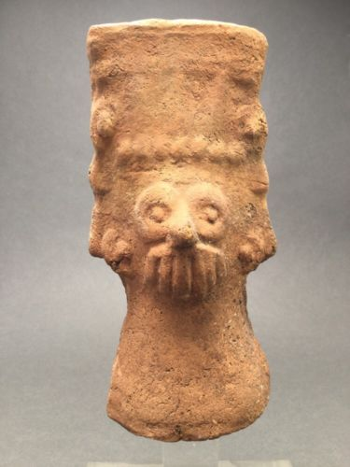

precolumbian terracotta tlaloc figure ex. Melvin Dwork
Item price | $99.00
Quantity | 1
Item number | 281976792152
Shipping service | USPS Priority Mail

Sales order
Sold by jeanpier_360 ( 100 )

Delivery package 1 of 1
Estimated delivery Saturday, Apr 9, 2016
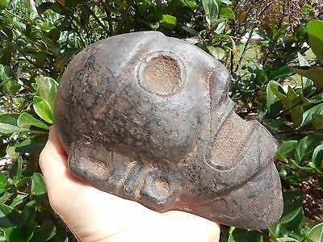

TAINO PRE- COLUMBIAN BLACK STONE HEAD
Item price | $299.00
Quantity | 1
Item number | 262353997406
Shipping service | USPS Priority Mail

Shipping address

Ralph J Coffman Jr
149 Atlantic Ave
Swampscott MA 01907-2427
United States

Order total

Subtotal | $398.00
Shipping | $17.15
Total
$415.15

Order placed on
Saturday, Apr 2, 2016
Payment method
PayPal
Payment date
Saturday, Apr 2, 2016

